AIM:
To study specialized Cisco IOS commands used for obtaining hardware, resource, diagnostic, and platform-level information from Cisco networking devices.
EQUIPMENT REQUIRED:
- Cisco Router/Switch
- PC/Laptop
- Console connection
- Cisco IOS/IOS XE device or suitable simulator
PROCEDURE:
- Connect the PC to the Cisco networking device.
- Open the device CLI.
- Enter privileged EXEC mode.
- Execute each command individually.
- Observe the information displayed by the device.
- Record the output and purpose of each command.
COMMANDS:
No. | Command | Where it is used
1 | show processes cpu sorted | Used to display active processes ordered by CPU utilization. Useful for identifying processes consuming significant CPU resources.
2 | show processes memory sorted | Used to display processes ordered by memory consumption. Useful for examining memory usage.
3 | show platform | Used on supported Cisco platforms to display hardware/platform-level information.
4 | show inventory | Used to identify installed hardware components, serial information, and hardware descriptions.
5 | show environment all | Used to monitor hardware environmental conditions such as temperature, power supplies, and fans on supported devices.
6 | show diagnostic result | Used on supported Cisco hardware to display results of hardware diagnostic tests.
7 | show controllers ethernet-controller | Used on supported switches to display low-level Ethernet-controller information and statistics.
8 | show interfaces transceiver | Used on supported switches/routers to obtain optical-transceiver information for interfaces using SFP/GBIC modules.
9 | show license udi | Used to display the device's Unique Device Identifier information for licensing and hardware identification.
10 | show platform hardware qfp active statistics drop | Used on supported IOS XE platforms to inspect packet-drop statistics in the QuantumFlow Processor.

RESULT:
The specialized Cisco IOS commands were executed/studied and their respective applications were identified.

EXPERIMENT-2
AIM:
To design and study different types of network topologies using Cisco Packet Tracer and understand how network devices are interconnected in each topology.
EQUIPMENT REQUIRED:
- Computer or Laptop
- Cisco Packet Tracer
- PCs
- Switches
- Hubs
- Routers
- Copper Straight-Through cables
- Copper Cross-Over cables
TOPOLOGIES USED:
- Bus Topology
- Star Topology
- Ring Topology
- Mesh Topology
- Tree Topology
- Hybrid Topology
PROCEDURE:
A. Bus Topology
- Open Cisco Packet Tracer on the computer.
- From the End Devices section, select the required number of PCs and place them in the workspace.
- Select a suitable central connecting device according to the Packet Tracer implementation being demonstrated.
- Arrange the PCs in a straight-line/linear arrangement to represent the bus structure.
- Select the appropriate cable from the Connections section.
- Connect the devices according to the selected bus-topology design.
- Click each PC and open Desktop → IP Configuration.
- Assign a unique IP address to each PC. For example:
  - PC0 – 192.168.1.1
  - PC1 – 192.168.1.2
  - PC2 – 192.168.1.3
  - PC3 – 192.168.1.4
- Use the same subnet mask, such as 255.255.255.0, for the PCs.
- After completing the connections, wait until the links become active.
- Use the Add Simple PDU tool or the ping command from the PC Command Prompt to test connectivity where applicable.
- Observe the final linear arrangement and take a screenshot of the completed topology.
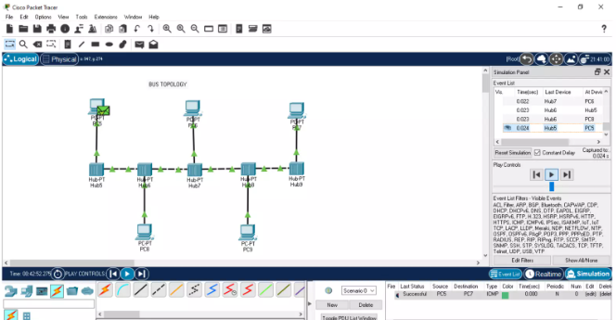
B.Star Topology
- Open a new workspace in Cisco Packet Tracer.
- From Network Devices → Switches, select a switch and place it at the center of the workspace.
- From End Devices, select four or more PCs.
- Place the PCs around the central switch.
- Select Copper Straight-Through Cable from the Connections menu.
- Connect PC0 FastEthernet0 to a port such as Switch FastEthernet0/1.
- Connect PC1 to another switch port, such as FastEthernet0/2.
- Continue connecting each PC to a separate port on the central switch.
- Open the configuration of each PC.
- Navigate to Desktop → IP Configuration.
- Assign different IP addresses to all PCs within the same network.
- Wait for the link indicators to turn green.
- Open the Command Prompt of one PC.
- Use the ping command to test connectivity with another PC.
- Observe that all PCs are connected through the central switch.
- Take a screenshot showing the completed star topology.
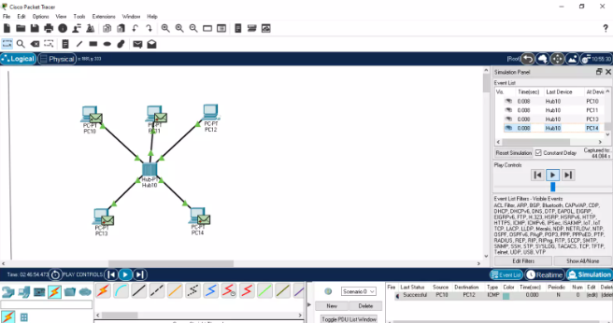
C. Ring Topology
- Open a new Cisco Packet Tracer workspace.
- Select multiple switches from Network Devices → Switches.
- Place the switches in a circular arrangement.
- For example, place four switches as:
  - Switch0 at the top
  - Switch1 on the right
  - Switch2 at the bottom
  - Switch3 on the left
- Select the appropriate cable from the Connections section.
- Connect Switch0 to Switch1.
- Connect Switch1 to Switch2.
- Connect Switch2 to Switch3.
- Finally, connect Switch3 back to Switch0 to complete the closed loop.
- Add PCs to the switches if end-device connectivity needs to be demonstrated.
- Connect each PC to its corresponding switch.
- Assign unique IP addresses to the PCs using Desktop → IP Configuration.
- Verify that the links between the devices are active.
- If necessary, use the ping command to test communication between end devices.
- Observe the closed-loop arrangement of the network.
- Take a screenshot of the completed ring topology.
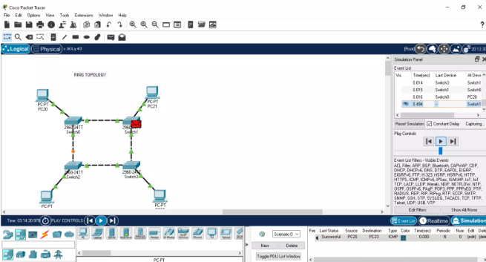

D. Mesh Topology
- Open a new workspace in Cisco Packet Tracer.
- Select multiple routers or switches according to the required mesh design.
- Place the devices in the workspace with sufficient space between them.
- Connect the first device to the second device.
- Connect the first device to the third device.
- Continue connecting the devices so that multiple independent paths exist between the network devices.
- For a full mesh, establish a direct connection between every pair of network devices.
- Use the appropriate cable for each connection.
- Add PCs to the network if required.
- Connect the PCs to their respective network devices.
- Configure appropriate IP addresses on the end devices and interfaces.
- Ensure that devices requiring Layer 3 communication have appropriate IP addresses and routing configuration.
- Test connectivity using the ping command.
- Observe that the topology contains multiple paths between network devices.
- Take a screenshot showing the completed mesh topology.
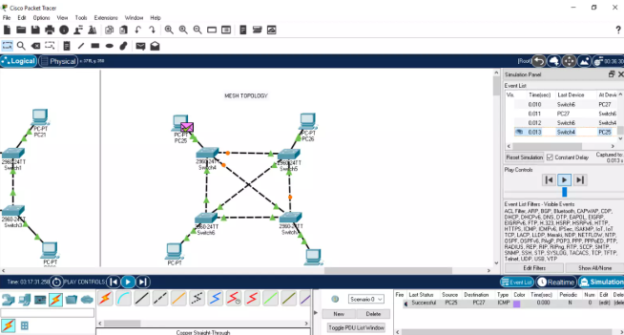
E. Tree Topology
- Open a new workspace in Cisco Packet Tracer.
- Select one switch to act as the root/central device.
- Place the root switch at the top of the workspace.
- Add two or more switches below the root switch.
- Connect the root switch to each lower-level switch.
- Add additional switches below the second-level switches if required.
- Connect the additional switches to their respective parent switches.
- Add PCs below the lowest-level switches.
- Connect each PC to an available switch port using a suitable cable.
- Assign IP addresses to the PCs using Desktop → IP Configuration.
- Configure the devices according to the requirements of the topology.
- Check that all physical links are active.
- Test communication between selected PCs using the ping command.
- Observe the hierarchical structure formed by the interconnected switches.
- Take a screenshot of the completed tree topology.
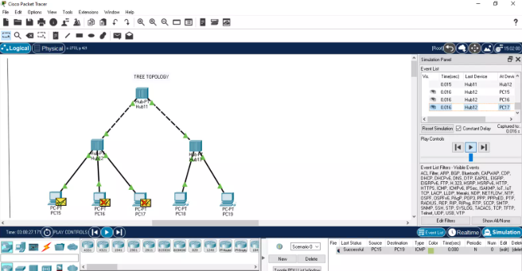

F. Hybrid Topology
- Open a new workspace in Cisco Packet Tracer.
- Select devices required to create two or more different topology structures.
- For example, create one section using a star topology and another section using a tree or bus-style arrangement.
- Build the first topology section independently.
- Build the second topology section next to the first section.
- Select an appropriate router or switch to interconnect the two sections.
- Connect the first topology to the interconnecting device.
- Connect the second topology to the same device or to another appropriate device.
- Add PCs to both sections.
- Connect the PCs to their respective switches.
- Assign suitable IP addresses to the end devices.
- Configure the required interfaces and network settings.
- Verify that all required physical connections are active.
- Test communication between devices in the different sections using the ping command.
- Observe how two or more different topology structures have been combined to form one network.
- Take a screenshot of the completed hybrid topology.
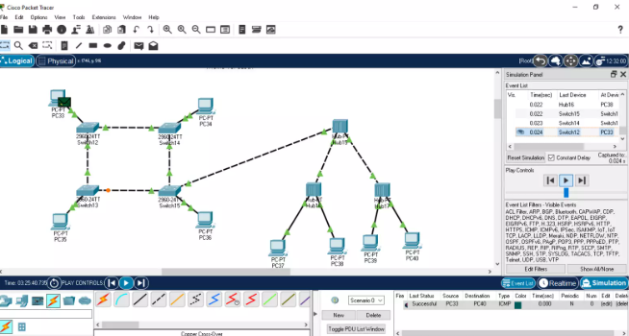
Result
The Bus, Star, Ring, Mesh, Tree, and Hybrid network topologies were designed and implemented using Cisco Packet Tracer. The arrangement and interconnection of devices in each topology were studied successfully.

EXPERIMENT – 3
Aim
To design and implement a Local Area Network (LAN) using Cisco Packet Tracer by connecting multiple computers through a network switch and to verify communication between the connected devices.
Equipment Required
- Computer/Laptop
- Cisco Packet Tracer
- 1 Cisco 2960 Switch
- 4 PCs
- Copper Straight-Through cables
Procedure
- Open Cisco Packet Tracer and create a new workspace.
- From the Network Devices section, select Switches and place one Cisco 2960 switch in the workspace.
- From End Devices, select PC and place four PCs in the workspace. They will appear as PC0, PC1, PC2, and PC3.
- Arrange the four PCs around the switch so that the switch acts as the central connecting device.
- Select Connections from the bottom-left menu and choose Copper Straight-Through cable.
- Connect PC0 FastEthernet0 to Switch FastEthernet0/1.
- Connect PC1 FastEthernet0 to Switch FastEthernet0/2.
- Connect PC2 FastEthernet0 to Switch FastEthernet0/3.
- Connect PC3 FastEthernet0 to Switch FastEthernet0/4.
- Wait for the connection indicators to become green, showing that the physical connections are active.
- Click PC0 → Desktop → IP Configuration.
- Select Static and assign:
- IP Address: 192.168.10.1
- Subnet Mask: 255.255.255.0
- Configure PC1 with:
- IP Address: 192.168.10.2
- Subnet Mask: 255.255.255.0
- Configure PC2 with:
- IP Address: 192.168.10.3
- Subnet Mask: 255.255.255.0
- Configure PC3 with:
- IP Address: 192.168.10.4
- Subnet Mask: 255.255.255.0
- Leave the Default Gateway empty because all four PCs belong to the same LAN and no router is required for communication within this network.
- To verify the LAN, open PC0 → Desktop → Command Prompt.
- Enter the following command to test communication with PC1:
ping 192.168.10.2
- Similarly, test communication with PC2 and PC3:
ping 192.168.10.3
ping 192.168.10.4
- Observe the replies displayed by the ping command. Successful replies confirm that the PCs can communicate through the switch.
- Click the switch and open its CLI if you want to observe the connected devices. Enter:
enable
show mac address-table dynamic
- The switch will display the MAC addresses learned from the connected PCs and the corresponding switch ports.
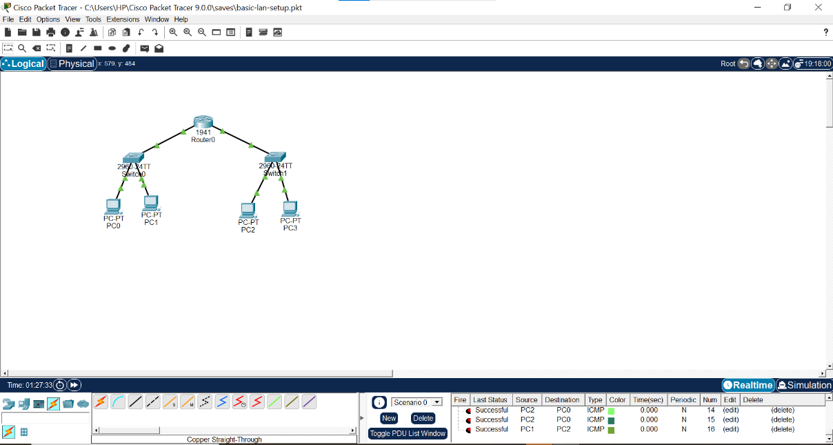
Result
A Local Area Network (LAN) consisting of four PCs and one Cisco 2960 switch was successfully designed and implemented in Cisco Packet Tracer. The PCs were assigned IP addresses in the same network and communication between the devices was successfully verified.

EXPERIMENT – 4
Aim
To design and implement a Metropolitan Area Network (MAN) using Cisco Packet Tracer by interconnecting multiple LANs through routers and to establish communication between the different network segments.
Equipment Required
- Computer/Laptop
- Cisco Packet Tracer
- 3 Cisco Routers
- 3 Cisco Switches
- 6 PCs
- Copper Straight-Through cables
- Serial cables, if required by the selected router interfaces
Procedure
- Open Cisco Packet Tracer and create a new workspace.
- Create three separate LAN sections to represent different locations within a metropolitan area.
- From Network Devices → Routers, place three routers in the workspace. Name them R1, R2, and R3.
- Arrange the three routers in a line. These routers will represent the connection between the different LANs.
- From Network Devices → Switches, place one Cisco switch near each router.
- From End Devices, place two PCs near each switch. This gives a total of six PCs.
- Connect the PCs of the first LAN to Switch 1 using Copper Straight-Through cables.
- Connect Switch 1 to Router R1.
- Similarly, connect the two PCs of the second LAN to Switch 2, and connect Switch 2 to Router R2.
- Connect the two PCs of the third LAN to Switch 3, and connect Switch 3 to Router R3.
- Connect Router R1 to Router R2 to create the first inter-LAN connection.
- Connect Router R2 to Router R3 to create the second inter-LAN connection.
- Assign IP addresses to the PCs in the first LAN. For example:
- PC0 – 192.168.10.10
- PC1 – 192.168.10.11
- Subnet Mask – 255.255.255.0
- Assign IP addresses to the PCs in the second LAN:
- PC2 – 192.168.20.10
- PC3 – 192.168.20.11
- Subnet Mask – 255.255.255.0
- Assign IP addresses to the PCs in the third LAN:
- PC4 – 192.168.30.10
- PC5 – 192.168.30.11
- Subnet Mask – 255.255.255.0
- Configure the router interfaces connected to each LAN with suitable gateway addresses, such as:
- R1 LAN interface – 192.168.10.1
- R2 LAN interface – 192.168.20.1
- R3 LAN interface – 192.168.30.1
- Configure the router-to-router interfaces with separate network addresses so that the routers can communicate with one another.
- Configure appropriate routing between R1, R2, and R3 so that traffic can travel from one LAN to another.
- On each PC, configure the Default Gateway according to its LAN:
- First LAN → 192.168.10.1
- Second LAN → 192.168.20.1
- Third LAN → 192.168.30.1
- Open the Command Prompt of PC0.
- Test communication with PC2 by entering:
ping 192.168.20.10
- Test communication with PC4 by entering:
ping 192.168.30.10
- If replies are received, communication between the different LANs has been established.
- Observe the complete topology consisting of three LANs interconnected through routers.
- Take a screenshot of the completed MAN topology and attach it under the Result section.
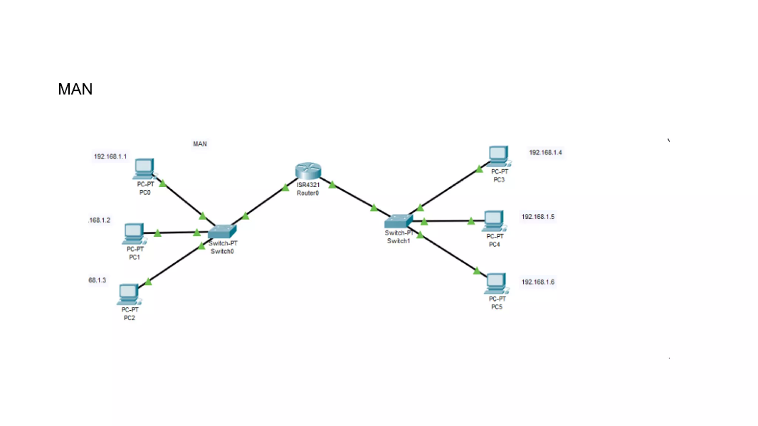
Result
A Metropolitan Area Network (MAN) consisting of three interconnected LANs was successfully designed and implemented using Cisco Packet Tracer. Communication between the different LAN segments was successfully established through the

EXPERIMENT – 5
Aim
To design and implement a Wide Area Network (WAN) using Cisco Packet Tracer by connecting multiple geographically separated LANs through routers and to verify communication between the networks.
Equipment Required
- Computer/Laptop
- Cisco Packet Tracer
- 2 Cisco Routers
- 2 Cisco 2960 Switches
- 4 PCs
- Copper Straight-Through cables
- Serial DCE/DTE cable
Procedure
- Open Cisco Packet Tracer and create a new workspace.
- Create two separate LANs to represent two different locations.
- From Network Devices → Routers, select two routers and place them in the workspace. Name them R1 and R2.
- From Network Devices → Switches, select two Cisco 2960 switches and place one switch near each router.
- From End Devices, place four PCs. Place two PCs near the first switch and two PCs near the second switch.
- Connect the first two PCs to Switch 1 using Copper Straight-Through cables.
- Connect Switch 1 to the appropriate Ethernet interface of Router R1.
- Connect the other two PCs to Switch 2 using Copper Straight-Through cables.
- Connect Switch 2 to the appropriate Ethernet interface of Router R2.
- Connect R1 and R2 using a Serial DCE/DTE cable. This serial connection represents the WAN link between the two different locations.
- Configure the PCs in the first LAN with the following addresses:
- PC0 – 192.168.10.10
- PC1 – 192.168.10.11
- Subnet Mask – 255.255.255.0
- Default Gateway – 192.168.10.1
- Configure the PCs in the second LAN:
- PC2 – 192.168.20.10
- PC3 – 192.168.20.11
- Subnet Mask – 255.255.255.0
- Default Gateway – 192.168.20.1
- Configure the LAN interface of R1 with:
IP Address: 192.168.10.1
Subnet Mask: 255.255.255.0
- Configure the LAN interface of R2 with:
IP Address: 192.168.20.1
Subnet Mask: 255.255.255.0
- Configure the serial interface connecting R1 and R2. Use a separate network, for example:
R1 Serial: 10.0.0.1
R2 Serial: 10.0.0.2
Subnet Mask: 255.255.255.252
- If R1 is the DCE side of the serial connection, configure a clock rate on the appropriate serial interface.
- Make sure the required router interfaces are enabled.
- Configure routing on R1 so that it knows how to reach the 192.168.20.0/24 network through R2.
- Configure routing on R2 so that it knows how to reach the 192.168.10.0/24 network through R1.
- Wait for the router and switch links to become active.
- Open the Command Prompt of PC0.
- Test communication with PC2 by entering:
ping 192.168.20.10
- Test communication with PC3:
ping 192.168.20.11
- Successful replies indicate that data can travel from the first LAN through R1 → WAN link → R2 → second LAN.
- Observe the complete WAN topology in the Packet Tracer workspace.
- Take a screenshot of the completed topology and attach it in the Result section.
Result
A Wide Area Network (WAN) connecting two separate LANs through two routers was successfully designed and implemented using Cisco Packet Tracer. Communication between the two LANs was successfully established through the WAN link.

